Jennifer DeVore

16 March 2020

CIS 435

**Unit 3 Graded Exercise 1: INSERT, UPDATE, DELETE Data, and Using Data Types**

**1. Write SELECT INTO statements to create two test tables named VendorCopy and InvoiceCopy that are complete copies of the Vendors and Invoices tables. If VendorCopy and InvoiceCopy already exist, first code two DROP TABLE statements to delete them.**

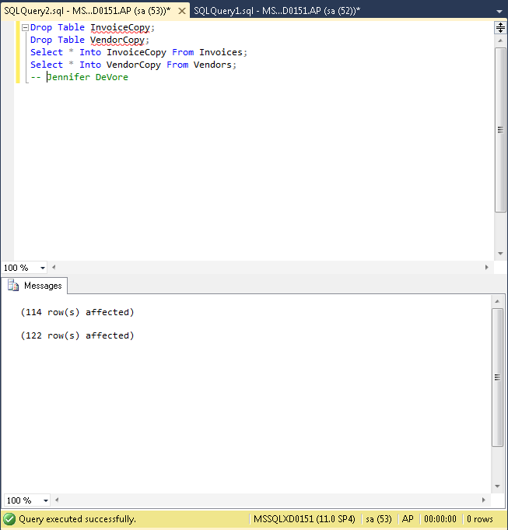

I created the copies and then was able to delete them so I could do all of the exercise.

**2. Write an INSERT statement that adds a row to the InvoiceCopy table with the following values: VendorID: 32 InvoiceTotal: $434.58 TermsID: 2 InvoiceNumber: AX-014-027 PaymentTotal: $0.00 InvoiceDueDate: 07/8/12 InvoiceDate: 6/21/12 CreditTotal: $0.00 PaymentDate: null**

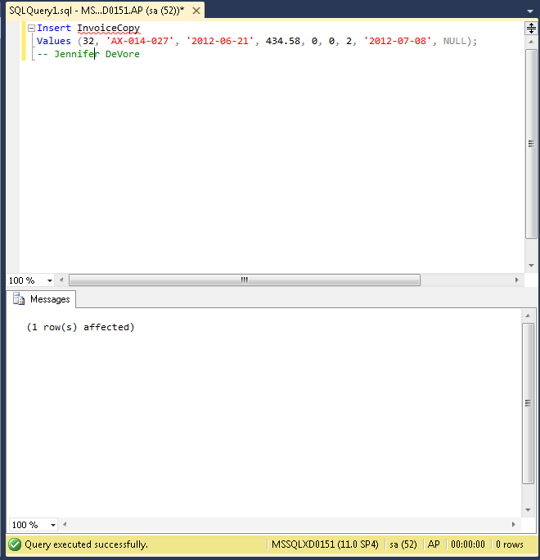

**3. Write an INSERT statement that adds a row to the VendorCopy table for each non-California vendor in the Vendors table. (This will result in duplicate vendors in the VendorCopy table.)**

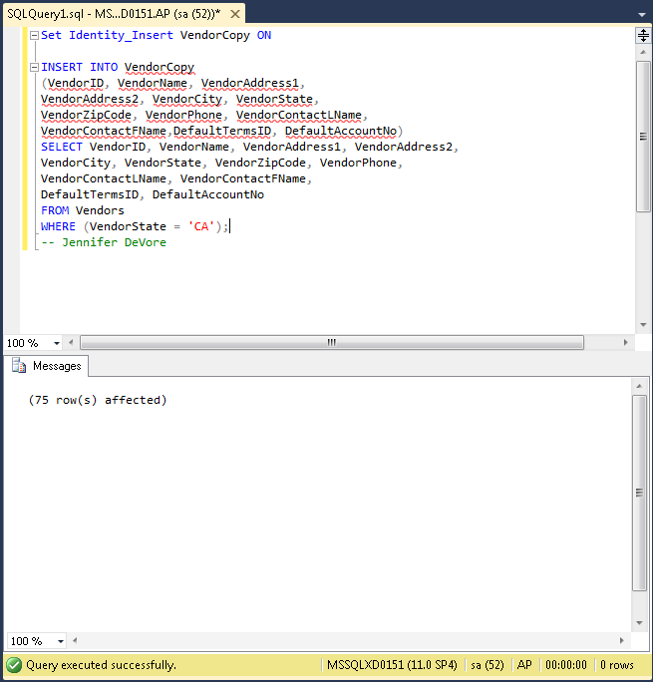

**4. Write an UPDATE statement that modifies the VendorCopy table. Change the default accoount number to 403 for each vendor that has a default account number of 400.**

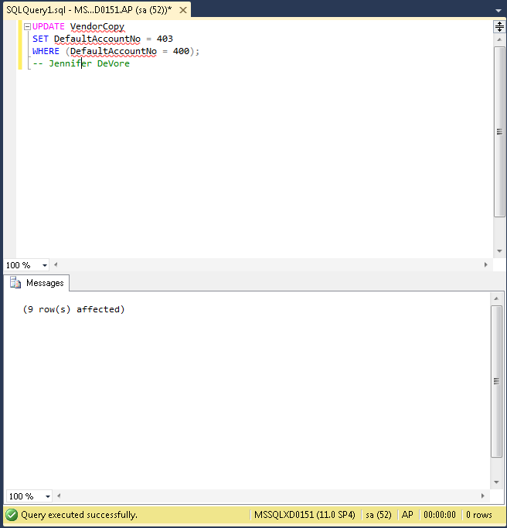

1. **Write a SELECT statement that returns four columns based on the InvoiceTotal column of the Invoices table:**

• **Use the CAST function to return the first column as data type decimal with 2 digits to the right of the decimal point.**

• **Use CAST to return the second column as a varchar.**

• **Use the CONVERT function to return the third column as the same data type as the first column.**

• **Use CONVERT to return the fourth column as a varchar, using style 1.**

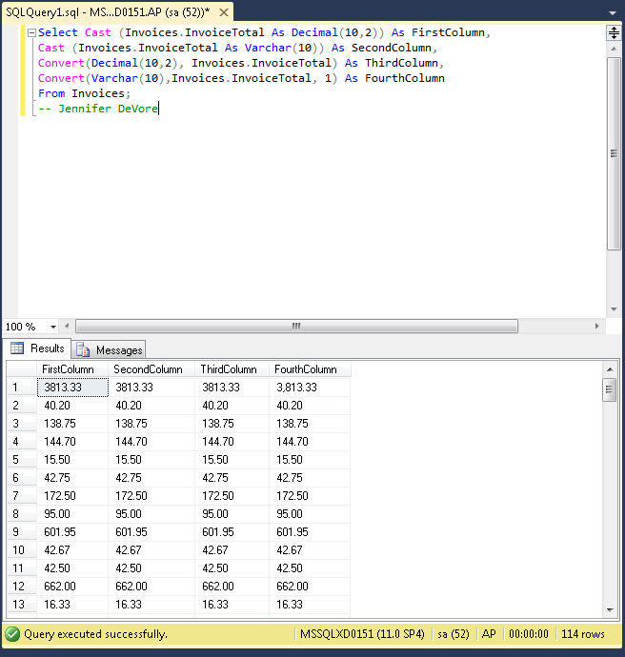

1. **Write a SELECT statement that returns four columns based on the InvoiceDate column of the Invoices table:**

• **Use the CAST function to return the first column as data type varchar.**

• **Use the CONVERT function to return the second and third columns as a varchar, using style 1 and style 10, respectively.**

• **Use the CAST function to return the fourth column as data type real.**

